Title Title Title Title Title
Written in Palatino Linotype Font 14 Pt, Bold
(maximum 12 words)

Author1), Author2), etc.
[Font Palatino Linotype 12, Bold]
¹University Name, Country (Author 1)
²University Name, Country (Author 2)
Correspondence author: Name, E-mail, Country

Abstract
[Palatino Linotype 12, Bold]

The abstract contains the key issues, research objectives, method/approach, and research results. The abstract is written in a single paragraph, not exceeding 200 words. [Palatino Linotype 10, justified, single spacing, and upright/non-italic].

Keywords: Maximum 5 keywords separated by commas. [Font Palatino Linotype 10, single spacing, and upright/non-italic]

Article History:
Received: February 17, 2026 ; Revised: February 20, 2026 ; Accepted: February 27, 2026
DOI: 10.46491/jptc.v6i1.2813
© 2026 by the authors. Submitted for possible open access publication under the terms and conditions of the Creative Commons Attribution Share Alike (CC BY-SA) license (https://creativecommons.org/licenses/by-sa/4.0/)

Introduction [Palatino Linotype 14pt, Bold]
The introduction covers the background of the research issue or problem, along with the urgency and rationale of the research. The research objectives and the proposed problem-solving approach are presented in this section. A relevant literature review and hypothesis development (if any) are included in this section. [Palatino Linotype, 12pt, normal, justified].
Research Method [Palatino Linotype 14pt, Bold]
The research method explains the research design/approach (quantitative, qualitative, case study, action research, R&D, or bibliometric review), the population and sample or research subjects, the data collection techniques and instruments used, and the data analysis techniques applied. [Palatino Linotype, 12pt, normal, justified].
Results and Discussion [Palatino Linotype 14pt, Bold]
This section presents the research results that have been processed and analyzed, accompanied by a discussion linking the findings to relevant theory or prior research, which may be supplemented with supporting tables, charts, or figures. [Palatino Linotype, 12pt, normal, justified].
Subsection [12pt, Bold]
Text [Palatino Linotype, 1 column, 12pt, justified]. Text [Palatino Linotype, 1 column, 12pt, justified]. Text [Palatino Linotype, 1 column, 12pt, justified]. Text [Palatino Linotype, 1 column, 12pt, justified].
Sub-subsection [12pt, justified, italic]
Text [Palatino Linotype, 1 column, 12pt, justified]. Text [Palatino Linotype, 1 column, 12pt, justified]. Text [Palatino Linotype, 1 column, 12pt, justified]. Text [Palatino Linotype, 1 column, 12pt, justified].
Table 1. Student Distribution Frequency
No | Interval | Frequency | % | Category
1 | 85 - 100 | 59 | 28.37 | Very Good
2 | 75 - 84 | 93 | 44.71 | Good
3 | 65 - 74 | 37 | 17.79 | Average
4 | 55 - 64 | 19 | 9.13 | Bad
Total |  | 208 | 100.00

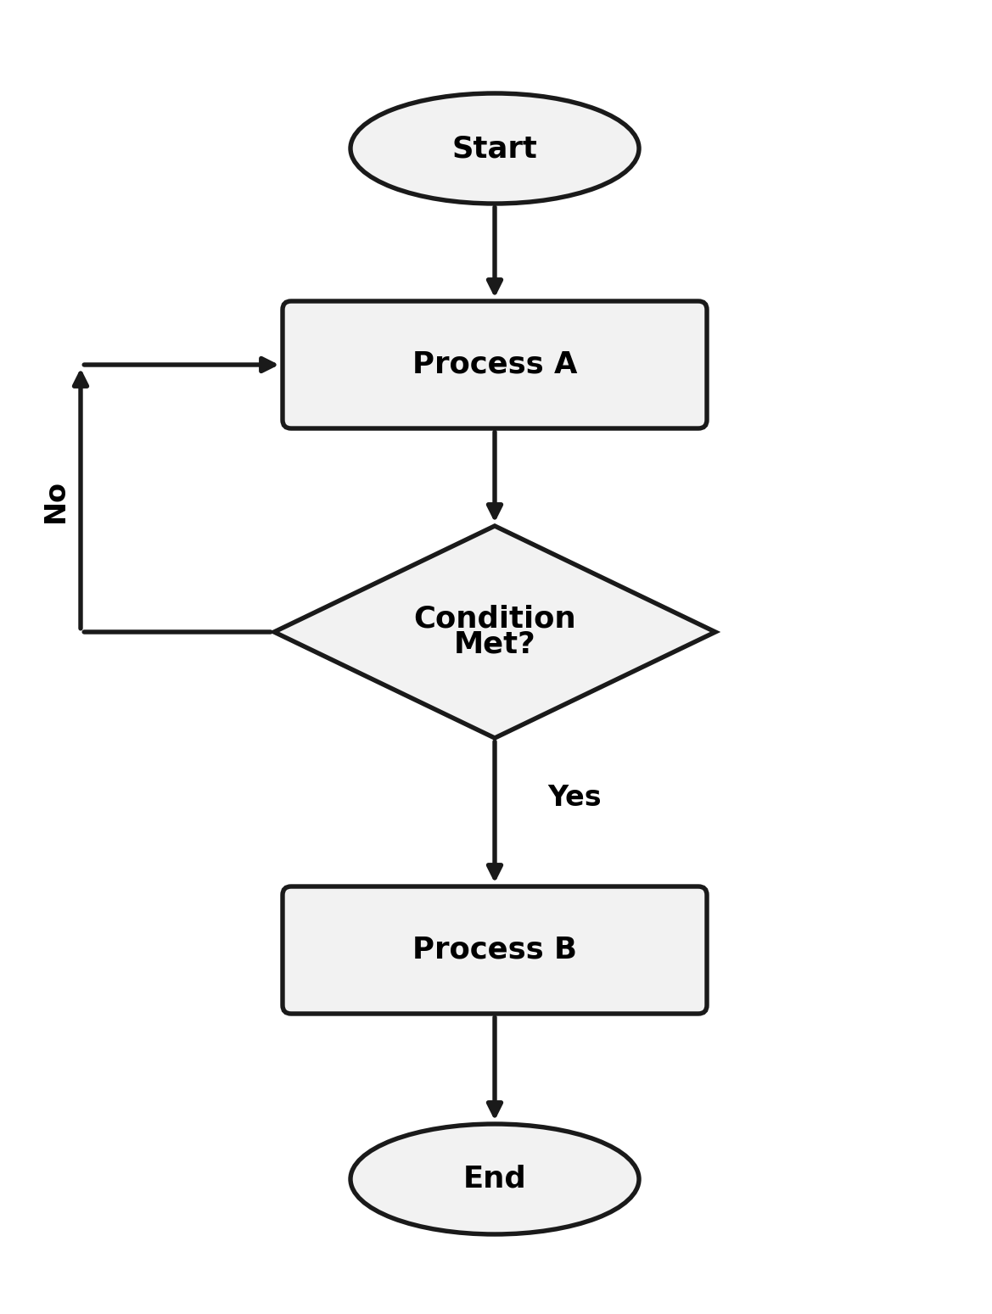

Figure 1. Diagram/Flowchart

Conclusion [Palatino Linotype 14pt, Bold]
The conclusion contains a brief summary of the research results and discussion, and may include suggestions or recommendations for future research. [Palatino Linotype, 12pt, normal, justified].
References [Palatino Linotype 14pt, Bold]
References are written using the American Psychological Association (APA) format. [Palatino Linotype, 1 column, 12pt, justified]. [Palatino Linotype, 1 column, 12pt, justified]. [Palatino Linotype, 1 column, 12pt, justified]. [Palatino Linotype, 1 column, 12pt, justified].

